

Coogee Triathlon Club

Race Information

Introduction
Welcome to Coogee Triathlon Club (CTC).
Whether you are a seasoned triathlete or this is your first race, we are delighted that you are joining one of our races.
Please check on our website for the dates for each of these races and for links to the entry pages. Please note that there are no entries on the day so make sure you enter online to avoid disappointment.
We normally do two or three club sprint distance triathlons (swim: 750m, cycle: 20kms and run: 5kms) over the summer season.
You do not have to be a member of CTC (or any other triathlon club) to take part in our races and all are welcome. Participants of sanctioned events who do not hold an AusTriathlon Annual Membership that includes a racing licence, must pay a One Day Licence fee to contribute to the costs of running the sport of triathlon.
Our races are sanctioned by AusTriathlon and are subject to the AusTriathlon rules: https://www.triathlon.org.au/rules/
By entering, you are agreeing to comply with these rules and the other waivers which you agree to upon entering the race.
If you have any questions on the day, please speak to the Race Director or one of the volunteers.
We would love you to stick around after the race to discuss the race and, more importantly, to enjoy a BBQ with your fellow competitors.
The information provided in this document is subject to change.
Enjoy your race.
CTC Committee.

General
Location
CTC club races are held at Heffron Park with the swim at Des Renford pool. There is normally ample parking in the Des Renford Leisure Centre car park.
Registration
There are no registrations on the day. Please make sure that you enter online. We normally open registration at 6:15am.
Please see details in your athlete email which will be sent the week of the race, and be on time.
Timing Chip
Please make sure you collect your timing chip at registration.
Wear your timing chip on your left ankle and always cross the timing mat when entering and exiting the transition area so your times are recorded.
After the race, you are responsible for returning your timing chip to a volunteer and you may be liable for charges for any unreturned/lost timing chips.
Toilets
There are public toilets at Heffron Park.
Transition and equipment set-up
Transition will open at 6:15am, and will close promptly at 7am, before the start of the race. Please make sure you are there in plenty of time to set up your bike and run kit.
Equipment checklist for first-timers:
- Swimmers or trisuit;
- Googles and cap;
- Bike – make sure your bike is in good working order and the tyres are pumped up and ready to go;
- Helmet – make sure your helmet is on before you take your bike off the rack;
- Bike shoes and socks;
- Sunnies;
- Water and nutrition (eg energy gels);
- Runners;
- Visor/Cap.
If you have questions about transition set-up, there will be plenty of people around to ask.
When entering and leaving for both T1 and T2, make sure you cross the timing mat so we can record your time.

Race Rules
By entering the race, you are agreeing to comply with the Triathlon New South Wales rules. These can be reviewed here:
https://www.triathlon.org.au/rules/
Race Officials
If you have any questions on the day, please speak to the Race Director or a volunteer. The CTC Committee would like to thank the volunteers who give up their time to come and provide such great support both behind the scenes and on race day. Make sure you give a wave and smile on your way past!
Pre-race briefing
Please make sure you attend the race briefing which will be at 7:00am before the race start time. The Race Director will advise of any last-minute course changes and provide any other necessary information.
BBQ
Please join us for a BBQ immediately after the race.
Race results
We have four race categories – U35 Male, U35 Female, O35 Male and O35 Female. We will announce the winners of these categories immediately after the race and will publish the full race results on our website after the race.

Triathlons

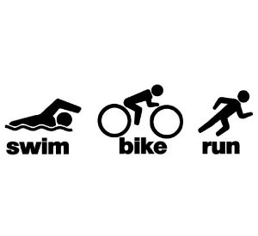

Transition Map

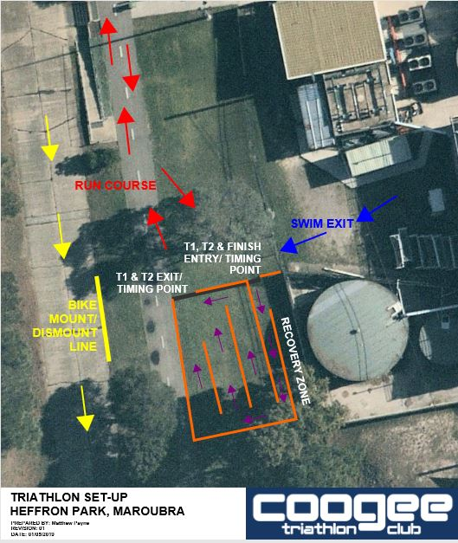

Swim
Distance: 750 metres (15 lengths of 50m pool – self-counted)
The swim leg of the summer triathlon races is in Des Renford Pool.
The swim is self-seeded. We normally have four lanes:
- Lane 1: sub-1:45/100m
- Lane 2: 1:45 – 1:55/100m
- Lane 3: 1:55 – 2:05/100m
- Lane 4: above 2:05/100m
Please seed yourselves in the correct lane for your swim pace. Race officials may need to move people around in there are too many people in one lane.
It can be busy and frantic in the first length (and particularly in the first turn) so please hang back if you are a bit nervous. It normally spreads out after the first couple of lengths. Please avoid doing tumble turns to limit kicking other swimmers.
We start at the shallow end of the pool (in-water start) and swim 750 metres (15 lengths) so you finish at the deep end of the pool. If safe to do so, you can use the steps to exit the pool. Otherwise, there will be volunteers to help swimmers exit the pool.
Please make sure you count your own lengths.
To get to T1, you go through the gates near the deep end of the pool and through to the bikes.

Bike Course
Distance: 20kms (10 laps – self-counted)
When exiting T1, do not mount your bike until you are on the bike track. Please check before mounting your bike for other cyclists already out on the course and be careful when setting off. Please also check when you are finishing the bike leg for any other cyclists when you are coming into T2.
Please keep left and pass on the right and call out when passing other cyclists. Drafting is not permitted.
The course is 10 laps of the Heffron Bike Track and is detailed in the course map below.
Please make sure you count your own laps.
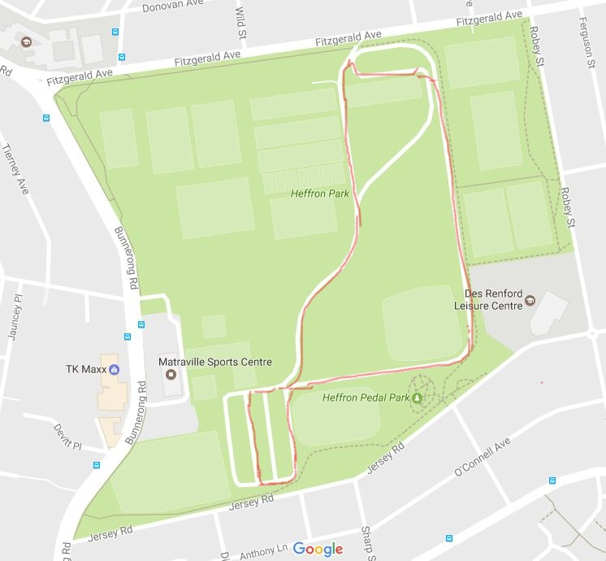

Run Course
Distance: 5kms (2 laps – self-counted)
The course is two 2.5km loops along the footpath next to Heffron Bike Track and is detailed in the course map below. There is one aid station close to transition which will have water only.
Please make sure you count your own laps.
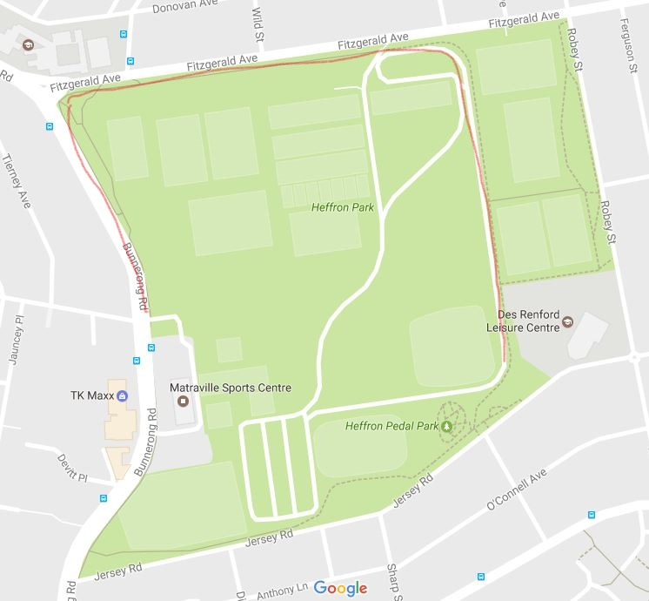

Duathlons


Transition Map

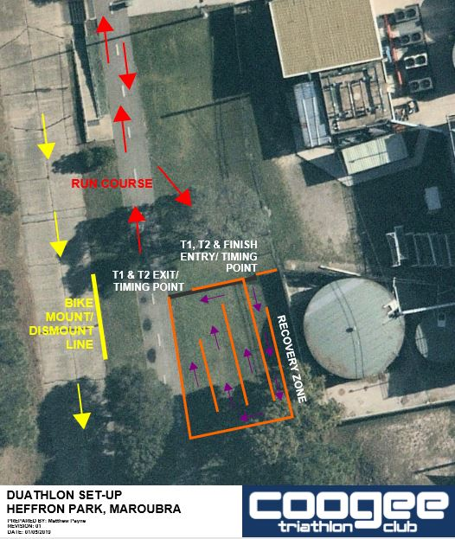

Run Course 1
Distance: 2.5kms (1 lap – self-counted)
The first run is one 2.5km loop along the footpath next to Heffron Bike Track and is detailed in the course map below. There is one aid station close to transition which will have water only.
Please make sure you count your own laps.
Bike Course
Distance: 20kms (10 laps – self-counted)
Do not mount your bike until you are on the bike track. Please check before mounting your bike for other cyclists already out on the course and be careful when setting off. Please also check when you are finishing the bike leg for any other cyclists when you are coming back into transition.
Please keep left and pass on the right and call out when passing other cyclists. Drafting is not permitted.
The course is 10 laps of the Heffron Bike Track and is detailed in the course map below.
Please make sure you count your own laps.

Run Course 2
Distance: 5kms (2 laps – self-counted)
The course is two 2.5km loops along the footpath next to Heffron Bike Track and is detailed in the course map below. There is one aid station close to transition which will have water only.
Please make sure you count your own laps.

